

Asia Pacific College

School of Computer and Information Technology

Magallanes, Makati City

**UNITY HOUSEKEEPING SYSTEM**

**Mr. Neal Rumbaoa**

(Client)

Submitted by

Project Manager - John Ryan L. Garcia

Project Developer - Earl Peter O. Gonzaga

Documentation - Jimmy M. Famador Jr

Project Developer - Tyronne Joshua U. Betita

Submitted to

Ms. Maricel P. Naviamos

(Professor)

August 31, 2017

**Table of Contents**

**Executive Summary 1**

**I. Introduction 2**

**1.1 Project Context 2**

**1.2 Purpose and Description 3**

**1.3 Objectives 4**

**1.3.1 General Objectives 4**

**1.3.2 Specific Objectives 4**

**1.4 Scope and Limitations 4**

**II. Review of Related Literature/Systems 6**

**2.1 Existing Systems: 6**

**III. Technical Background 29**

**3.1 Device Platform 29**

**3.2 Back End Framework 30**

**3.3 Resource Requirements 31**

**3.3.1 Hardware Requirements & Software Requirements 31**

**IV. Methodology, Results and Discussion 32**

**4.1 Requirements Analysis 32**

**4.1.1 Dataflow Diagram lvl 0 33**

**4.1.2 Dataflow Diagram lvl 1 34**

**4.1.3 Entity-Relationship Diagram 35**

**4.2 Requirements Documentation 37**

**4.2.1 Data Dictionary 37**

**Room Table 37**

**Room Type Table 37**

**Employee Table 40**

**Housekeeping log details Table 41**

**Checklist Items Table 41**

**Checklist Reference Table 42**

**Checklist Category Table 42**

**4.2.2 Glossary 43**

**4.2.3 Tables/Files Layout 44**

**4.2.4 Use Case Diagram 48**

**4.2.5 Use Case Narrative Report 49**

**4.2.6 User Stories 52**

**4.3 Gap Analysis 53**

**4.4 Design of Software, Systems, Product, and/or Processes 54**

**4.5 Description of the Prototype 59**

**4.6 Sequence Diagram 63**

**4.7 Activity Diagram 66**

**4.8 Proposed Conceptual Framework 70**

**4.9 Gantt Chart 71**

**V. Conclusions and Recommendations 72**

**VI. Appendices 73**

**VII. Bibliography 79**

**List of Tables**

**Table IV‑1 36**

**Table IV‑2 37**

**Table IV‑3 38**

**Table IV‑4 39**

**Table IV‑5 40**

**Table IV‑6 41**

**Table IV‑7 41**

**Table IV‑8 41**

**Table IV‑9 42**

**Table IV‑10 48**

**Table IV‑11 49**

**Table IV‑12 50**

**Table IV‑13 51**

**Table IV‑14 51**

**Table IV‑15 51**

**Table IV‑16 52**

**List of Figures**

**Figure IV‑1 32**

**Figure IV‑2 33**

**Figure IV‑3 34**

**Figure IV‑4 47**

**Figure IV‑5 62**

**Figure IV‑6 63**

**Figure IV‑7 63**

**Figure IV‑8 64**

**Figure IV‑9 65**

**Figure IV‑10 66**

**Figure IV‑11 67**

**Figure IV‑12 68**

**Figure IV‑13 69**

# Executive Summary

Taal Vista Hotel is one of the hotels in the Philippines that offers a first-class accommodation with a construction that can give guests a vibrant feeling. There are six types of room that lets the guest choose what type of room best fits their need.

Taal Vista Hotel wants to have an accurate record of the productivity of each employee in the housekeeping management. So Unity Housekeeping System aims to create a mobile application that will help the employees of the housekeeping management with a cleaning report module that will provide a more accurate record of all the housekeeping records. The system will help the housekeeping inspectors to generate a check list in each type of hotel room for housekeepers and will serve as their record in tracking their productivity. The system includes a QR Code scanner that will be the tool in starting the time-in of each housekeeping employee.

Unity Housekeeping System will be a big part of Taal Vista Hotel’s housekeeping management because it will provide them with a more accurate tracking of productivity and an easy-to-use system.

**Chapter I**

**Introduction**

# Introduction

In 1939, Taal Vista Hotel was constructed at Aguinaldo Highway located in Tagaytay. Taal Vista has many accommodations where the hotel promotes different kinds of rooms. Taal Vista has several highlights such as the Traditional Folkloric dance, where the hotel lets guests experience the wonders of Tagaytay’s cultural heritage, the Weekend Market, where the guests enjoy Tagaytay’s fruits. Lastly, the hotel lets the guests relax and enjoy the hotel’s outdoor swimming pool and spa services. The group is being tasked to create a system for the hotel housekeeping management that keeps track of the housekeeping checklist in every single room.

## **Project Context**

Within the hotel industry, hotel management includes many concepts like food service, servicing guests, etc. Housekeeping management takes care of and accommodates the needs of every guest in the hotel. Housekeepers clean the hotel rooms and maintain a clean environment for their guests. They do this in order to achieve a satisfactory rating from customers. Currently, the housekeeping management has identified some problems that affect their service quality. These problems are slow housekeeping service and human errors. With the help of a housekeeping system, the Housekeeping Management can minimize the occurrence of these problems.

The proposed system will require QR codes in every hotel room. These QR codes will contain the hotel room number, status and task list depending on the type of the room. The housekeeper will update their status using the application to record their “time in” and “time out” of their task. The housekeeper will also record the tasks completed in the task list that is part of the system. After the housekeeper cleans the rooms assigned to him/her, the housekeeping supervisor will inspect each room that has been cleaned.

## **Purpose and Description**

The Unity Housekeeping System aims to help housekeeping staff with task management, room checking and room cleaning. The housekeeping inspector will be assigning the housekeeper to clean the room and the inspector will each room that the housekeeper maintained. This system aims to support the hotel staff in doing the housekeeping chores and checking the room for final updates and reports.

Another purpose of the system is to help housekeeping staff to be more productive by allowing the inspector to track the staff’s activities. It also allows the inspector to manage and monitor room cleaning for each type of hotel room.

`

## **Objectives**

### **General Objectives**

The general objective of the team in building the Unity Housekeeping system is to develop a system that will help Taal Vista Hotel’s housekeeping management and staff to do tasks in a more productive way.

### **Specific Objectives**

The Unity Housekeeping system contains the Hotel Room Cleaning Checklist Module that revolves around tracking the cleaning and checking of each hotel room. The Unity Housekeeping system will have an automated check list that lets the user track their time of work which can help them be motivated to be more productive.

## **Scope and Limitations**

The scope of the system will be focusing primarily for the housekeeping management of Taal Vista Hotel. The system will also concentrate on hotel management’s performance through the checking process and room cleaning maintenance. The Unity Housekeeping system is assigned to add task(s) to an inspector every time a housekeeper is done cleaning a room. Every housekeeping staff will be having an Android device that will be used in the checking and cleaning of room. However, the system cannot do real-time monitoring of the housekeepers. It is still necessary to implement an audit using CCTV cameras, so that the housekeeping management can have better tracking of the performance of each housekeeping staff.

**Chapter II**

**Review of Related Literature/Systems**

# Review of Related Literature/Systems

## **2.1 Existing Systems:**

**HOTELOGIX**

By definition, housekeeping is the general care, orderliness, and maintenance of business or property. However, in the article “Defining Housekeeping”, housekeeping refers to the management of duties and chores involved in the running of a household. This definition indicates the maintenance process in the business which offers hygiene and all ancillary support. There are several housekeeping systems in the internet, the HOTELOGIX have a good housekeeping system. According to my research the HOTELOGIX system can assign the task and lets you sustain your list of housekeeping staff with no breaking points and you can assign rooms based on blocks/floors or sort them based on their status to manage division of work. Then they go to the Task List, the daily list of housekeeping tasks is easy to print and work easy to divide and distribute amongst the staff. The work is made easier with tools to channel and sort rooms based on blocks and floors and their status. And when the rooms or floors encountered some problems the system also have room maintenance. You can get a simple task & messaging system for special requests. Maintenance and repair activities can be allocated by staff from same or other department. Specially, the system can automate changes in housekeeping status of the rooms and let the system change room to ‘Dirty’ on checkout, or a clean room to ‘Inspect’ on night audit. This features help reduce efforts on repetitive tasks and lessen the chance for errors. (Bhatnagar, B (2000) Property Management Simplified [online]. Available: <http://www.hotelogix.com/>. (March 2000)

**Virtual Resort Manager (VRM)**

The Virtual Resort Manager has taken the management system of housekeeping to a new level of ease and effectiveness. The system is centered on remarkable Housekeeping Scheduling Grid, which makes the scheduling, last minute changes of housekeeping charges directly to the vendor. Based from the site, from the grid the housekeepers which are assigned at the specific property level can be easily changed to fit changing conditions and workloads. The VRM is built as a single package with all functionality operating together as a single combined process and the benefit of this is the elimination of double tasks, increased speed of operation, and less chance of human error. And with VRM, the data of the customer is housed in discrete database with a redundant backup. This is a good scheme for the customer’s private information compared to the HOTELOGIX that only focuses on maintenance of the hotel. By having the possible security protection for the system, by always having most up to the minute backups available. (Wenk, P (2001) Virtual Resort Manager Housekeeping [online]. Available: <http://www.virtualresortmanager.com/housekeeping.asp>. (July 2017)

**KNOW Housekeeping**

Know housekeeping system there are sufficient features that can help the customers in a better way. First, the two way messaging for attendants and supervisor this feature set the communication from the customers, to the housekeepers and can elevate to supervisors to fix the issue. This scheme is important for the customer’s satisfaction to gratify their complaints in the room. Then the performance report, to monitor the complaints of the customers to the housekeeper of the hotel and to observe how well did they do. And Move around tracking, for real time tracking of cleaning progress and reduction of inspection time and focus on quality maintenance. This system is efficient compared to the previous systems that I’ve researched. This strategy can improve the housekeeping performance of the hotel. (2002, KNOW Housekeeping [online]. Available: <http://www.knowcross.com/know-housekeeping/>. (July 2017)

**FCS E-HOUSEKEEPING**

The FCS-Housekeeping Operation Management, it streamlines housekeeping operation with automated room assignment, proper inspection and management functionality. For the room, inspection and productivity matrices you can track all task progress and rest assured that no assignments fall off the radar. For uniqueness of the system they have a m-housekeeping, that can guarantee faster response times using mobile technology. With m-Housekeeping the IOS and Android is compatible for their application, so that the staff can access the full capabilities of e-Housekeeping wherever they may be. Housekeeping teams can update the status of cleaning and inspection assignments instantly, as well as carry out daily duties with just a touch of their fingertip. The software records every item in a better and systematic way that reduces the human effort. This allows the housekeeping to focus on the more productive work in a hotel like hygiene and cleanliness. This is the most unique system, because of their e-Housekeeping system that efficiently do the task easier and faster. (2008, Modern Housekeeping [online]. Available: <https://www.fcscs.com/e-housekeeping/?gclid=Cj0KCQjw7pHLBRDqARIsAFyKPa6JKWDnUgIUx_L7fGi-sl5hsjthBc1HZBWKNET6DOtMFbfj5nAOMgIaAhLxEALw_wcB>. (July 2017)

**Opti Keeper**

Optii Keeper is a hotel housekeeping software that is available in the market that is used by many hotels today. It is timely and professional housekeeping management that aims a goal for better guest experience and successful hotel operation. Optii keeper is innovative patent labor management that maximizes capability and productivity throughout the housekeeping function. It enables you to view and control your housekeeping operations in real-time, delivering insights and benchmarks to help you streamline your performance. It also allows guests to access rooms faster and eliminates communication between reception and housekeeping and helping you focus on your customer. It is fully mobile, Completely multi-lingual and user friendly. Current housekeeping software solutions cannot make a distinction between the patterns. The software estimates cleaning times by checking the guest type then optimizes the housekeeping schedules in real-time. To improve this housekeeping software, the software must include staff assistance to improve the hotel management functions. (2011), The Optimum Housekeeping Solution [online]. Available: <http://optiisolutions.com/>. (July 2017)

**Winter Halter**

WinterHalter is a great service for a housekeeping system, because winterhalter can provide hygiene, reliability sustainability and performance not only for the staffs but also for the customers. Efficiency and user-friendliness are top priorities for Winterhalter. This is why they are constantly working to optimize our products, both in form and content. With its state-of-the-art formulas, the Winterhalter range of detergents and warewashing hygiene products even more effective and precise. The winterhalter washing chemicals assortment makes handling easier, also, it quickly provides an overview of the product and its field of use which will make it user friendly for the users. The Winterhalter also provides catering hygiene program and they can be tailor kitchens. Their products will effectively clean all the materials and equipment in the kitchen. Guaranteeing kitchen hygiene is Winterhalter’s top priority, they also have created a well-thought out, language-independent system. It quickly provides an overview of the product and its field of use. The products they produce are recycled and environmental friendly each product in the Winterhalter environmental range has been formulated to minimize the impact on the environment. They utilize raw materials from renewable resources, are fully biodegradable and use recycled and recyclable packaging. (Winterhalter, K. (1947) winterhalter Housekeeping [online]. Available: <http://www.winterhalter.biz/>. (July 2017)

**Starwood Hotel Housekeeping**

The Housekeeping department is typically the largest in the hotel in terms of both the number of associates and annual operating budget Starwood offers housekeeping and laundry for a system. Much of a guest’s overall impression of the hotel relates to its cleanliness; therefore, Housekeeping associates play a crucial role in ensuring an exceptional guest experience. Ideal Housekeeping and Laundry associates are extremely detail-oriented. They strive to provide guests with clean and comfortable accommodations while away from home. From fresh bed linens to spotless bathrooms and immaculate lobbies, our associates are committed to upholding Starwood’s quality and cleanliness standards at all times. Unlike Winterhalter, Starwood focuses on making the guests comfortable, while winter halter focuses on hygiene given to the customers or users. (Hohman, R. (2007) Starwood Hotel & Resorts [online]. Available:https://www.glassdoor.com/Hourly-Pay/Starwood-Hotels-and-Resorts-Housekeeping-Hourly-Pay-E335_D_KO28,40.htm. (July 2017)

**Housekeeping-5s**

This system is designed for the housekeeping operators and supervisors. The role of this system is to monitor the daily flow of housekeeping tasks and keeps track of the progress of housekeepers. It also allows the job to be easier than not having a system. Unity Housekeeping system can also relate Housekeeping-5s because the role of Housekeeping-5s is similar to what the Unity application has. (CRIG (2005) Factory Systems [online]. Available: <https://www.factorysystems.eu/index-en.php?id=5s-en>. (July 2017)

**Hospital Housekeeping Systems**

Hospital Housekeeping Systems is a system that will make sure that the patients or the guests in a hospital receives proper healthcare from the housekeeping management. The system also has a module that focuses on the housekeeping services, equipment and supplies, and the housekeeping staff. The Hospital Housekeeping Systems is related somehow to the Unity Housekeeping system because it focuses on the housekeeping services and staff. (1975), HHS Housekeeping [online] Available: <https://www.hhs1.com/>. (July 2017)

**Home Sanctuary**

The Home Sanctuary’s housekeeping system role is to provide a scheduling service for the housekeeping management. The system includes a time schedule that will have the schedule for each housekeeping task. The time schedule includes the day, the time, and the number of tasks to do in each day and time. In conclusion, Home Sanctuary is mainly a housekeeping system that kees track of the schedule of the housekeeping management. (Ridge. R (2012) Housekeeping Schedules [online]. Available: <http://www.homesanctuary.com/rachelanne/2011/09/housekeeping-schedules-and-daily-home-management.html>. (July 2017)

**LLC**

LLC focuses on the integrated facilities of a housekeeping management. The system focuses on a support service system for the housekeepers and its facility or management. It is a hospital housekeeping system that also focuses on healthcare. The system has a module that will store every tasks given to the housekeeping management. (Connerly. C (2003) Living Learning in Community [online]. Available: <http://legacy.earlham.edu/~kohlhe/blog/archives/000768.html>. (July 2017)

**RoomKeyPMS**

The RoomKeyPMS is a housekeeping management system, according to my research the RoomKeyPMS streamlines a housekeeping operation with personalized schedules that can help the cleaning staff and assigning their different tasks. Also, live status tracking, that can support the assign inspector to check each room in the hotel with live status tracking. The RoomKeyPMS, can easily add or alter attendants and their targets to guarantee uninterrupted service. (Khaled. D (2010) Room Key PMS [online]. Available: <http://support.roomkeypms.com/>. (July 2017)

**SNAP PMS**

What is SNAP PMS? SNAP PMS is an online hotel property management system, an all in one hotel reservation and property management system designed for all types of small properties. SNAP PMS have an efficient housekeeping system. The SNAP PMS has an Internet Booking Engine, that can instantly deliver the reservations. The snap booking engine is mobile-friendly the guests can book via desktop, tablet, or even smart phones. Also, the SNAP PMS has a Channel Manager, that can manage booking channels via one click. Lastly, it has a Housekeeping Module that can help the housekeeping helpdesk to track arrivals, departures, and housekeeping duties easily. (2009), Online Hotel Property Management System [online]. Available: <http://www.snappms.com/>. (July 2017)

**TrigernixHMS**

TigernixHMS offers housekeeping management module that gives a great line of features that can enable the staff to manage the hotel’s housekeeping processes. Housekeeping room attendants and their supervisors directly record task information in the Housekeeping Management module making the whole work process basic, smooth, and fast. The help desk can manage staff competently through scheduling, task-allocation and inspection features. The TrigernixHMS can also define job roles and responsibilities, and assign specific tasks with required instructions to carry out the task. With housekeeping module, tasks can be overseen well in a convenient way, sticking to guidelines, fulfilling sanitation requirements of the Hotels Act. (2006), Hotel Management System [online]. Available: <https://www.tigernix.com/home/software/hotel-management-system>. (July 2017)

**Inspect2GO**

According to my research, several housekeeping system has the same modules that streamlines cleaning and other housekeeping tasks. But Inspect2GO hotel housekeeping are built to the unique needs of hospitality industry. The housekeeping examination instrument is a turnkey framework including inspection application, cloud database, and inspection management program. Conduct housekeeping quality audits on the mobile app. Use the housekeeping inspection scoring system rate and track performance. Store inspection data and photos on a database. The web-based management portal is especially powerful. Use the scheduling tool to schedule, assign, manage and track inspections and tasks. Send work orders to the maintenance or engineering department and track progress. Inspect2GO is very user-friendly that can help the hospitality industry to grow faster when it comes to inspection and tracking reports. (2006), Hotel Housekeeping Inspection Software [online]. Available: <http://inspect2go.com/hotels/housekeeping-software>. (July 2017)

**Hibox Housekeeper**

The Hibox Housekeeping system or app is convenient for the housekeeping management and its staff. It is very efficient and it works in partnership with other hotel service operations so everything is in sync. Hibox Housekeeping app is running on mobile devices and the team might gather some information to help in doing the Unity Housekeeping system. The Hibox Housekeeper is somehow related to the team’s system. It focuses on the cleaning and maintenance activities of the housekeeping management. The interface of Hibox Housekeeper is simple and it is user-friendly so the staffs can work on it so easily. Hibox Housekeeper has many features that the group can also use for their Unity Housekeeping system. The cleaning and maintenance activities can be recorded within the system. A user-friendly interface and simple design can make it very easy for the staff to use the application. (Granholm. S, (2011), HIBOX Houskeeping [online]. Available: <http://www.hibox.tv/index.shtml>. (July 2017)

**Resort Data Processing Housekeeping Management**

Resort Data Processing’s Housekeeping Management focuses on the resort’s housekeeping forecast, scheduling, and its history module which is programmed to improve the process of task completion assigned to each hotel housekeeping department. The system has one module for housekeeping that includes some features. It focuses on the forecasting of housekeeping requirements, the schedules of daily housekeeping, and the history of work in housekeeping management. At the updated system, the housekeeping management can now use mobile devices to change their room status and the time spent in working per room. The group can use this existing system because it is somehow related to some features of Unity Housekeeping System. It has the same console used. It uses mobile devices because the Unity Housekeeping System is a mobile application not just for Apple phones, but also Android phones. (1998), Resort Data Processing [online]. Available: <http://www.resortdata.com/>. (July 2017)

**Jinisys In-House Plus Housekeeping Management System**

Jinisys’ In-House Plus is a housekeeping system that provides features for efficient housekeeping tasks. With this system, housekeeping management has become easier, not just for staffs, but also the guests who enters the hotel room. In-House Plus has a voice-assisted rooms via mobile phones so that guests can contact the housekeeping management and guests can give feedback or suggestion for the hotel room. The In-House Plus also gives real-time updates for the cleaning information of each hotel room so that the housekeeping management is updated and they will know what to do in each hotel room. Lastly, there is a tracking module that tracks the status of the completed tasks done by the housekeepers. The group can gather information from the In-House Plus system because some features are related with the proposed features of Unity Housekeeping System. Plus, Jinisys is located in the Philippines. (Balagosa, J (2008) [online]. Available: <http://jinisyssoftware.com/products/>. (July 2017)

**acgil Housekeeping Management**

The acgil company combined the Housekeeping and Laundry Management in one system. It has a module that provides the management to monitor and manage housekeeping and laundry activities in a hospital, not in a hotel. The module includes a proper scheduling for the cleaning of each hospital room. Staffs are also appointed and given a role through this system. Quality control is also included in the acgil’s Housekeeping Management system. It is like a feedback module so that patients can give their feedback about the cleanliness of a hospital room. The group can obtain some data in acgil’s Housekeeping Management by understanding the features of its module properly. Some features are also related in the Unity Housekeeping System or application. (McLean, D (1993) [online]. Available: <http://www.acgil.com/products/smart_deals.htm>. (July 2017)

**SMS Service Management Systems**

The difference between the SMS Service Management Systems and the Unity Housekeeeping System or application is that the SMS Service Management Systems is implemented in a hospital for healthcare housekeeping and maintenance. The SMS Service Management Systems focuses on housekeeping and maintenance for public facilities or healthcares. It also has a maintenance module for the housekeepers. This system is flexible for the needs of other facilities and it is compatible with other hospital or clinic that wants a housekeeping management system. (2009), SMS Service Management [online]. Available: <https://www.fieldaware.com/>. (July 2017)

**Protel**

Protel housekeeping system relies on mobile application to work faster, save time and have more time for guests. The application includes the room state (occupied/vacant) and the status of the room (cleaned, dirty, touched, cleaning in progress, and checked). Protel’s mobile application also has the feature to send the guests’ bill and to create or edit maintenance orders. Lost and found management is also included in the mobile system it creates and edits entries, add new pictures using the smartphone. Items are immediately shown in Protel FrontOffice. (2017) Protel [online]. Available: <http://www.protel.net/> (July 2017)

**Payscale**

Payscale is a site where an hourly rate for hotel housekeeping system is analyzed. The site shows very helpful information on how a hotel housekeeping system works and what the basic routines are for the qualifying employees. (2017) Payscale [online]. Available: <http://www.payscale.com> (July 2017)

**WorldHotels**

Partnership is what worlhotels is aiming for. Worldhotels is a well-known hotel; they work in group with small hotels like Tivoli hotels & resorts, Ameron Hotels, Fleming hotels and many more. Their main goal in working together with non-affiliated hotel is to maximize the benefit as a group working with each partner. (2017) Worldhotels [online]. Available: <https://www.worldhotels.com/> (July 2017)

**Fairmont**

Services is what Fairmont is targeting, they offer different services for the guests for them to have a great hotel experience. 24/7 technology help desk in one of their services this is to solve guest ‘technology-related problems. (1999) Fairmont [online]. Available: <http://www.fairmont.com/> (July 2017)

**Waterfront**

Waterfront hotels offer service with hospitality where every employee is placed in the forefront of the service chain. Employees are guided to perform vital roles in realizing common yet critical and multi faced goals and objectives for the purpose of achieving customer satisfaction which is critical for a company to the overall business. (1995) Waterfront [online]. Available: <http://www.waterfronthotels.com.ph/> (July 2017)

**Grandmeneng**

The grandmeneng hotel which is located in davao delivers a housekeeping system where it provides quality services and livelihood of the guests. Housekeepers are required to serve the guests providing the tradition and culture of Davao. (Thompson. B, (2011) Grandmeneng [online]. Available: <http://www.grandmeneng.com>. (July 2017)

**Silk Hospitality**

The silks housekeeping system provides all areas of efficient running of the hotel's housekeeping department. It includes, bed making, waste disposal vacuuming, mopping, dusting, Spring cleaning and scheduled detail cleaning, Silk hospitality also provides cleaning all public areas and back of house storage and staff access areas. (1998) Silk Hospitality [Online] Available: <http://www.silkhospitality.com.au/why-outsource-housekeeping-services> (July 2017)

**Janiking**

Janiking’s housekeeping system runs a wide variety of housekeeping services programs; Unity housekeeping’s proposed system will be improved significantly with the different housekeeping services. (2017) Janiking [online]. Available: <https://www.janiking.com/commercial-cleaning-services/hotel-and-resort-housekeeping/> (July 2017)

**Momvoyage**

Momvoyage ‘s housekeeping system serves normal housekeeping operations but, they focus on precise and accurate work. Momvoyage hotels aim for the guest’s convenience and also to reach their satisfactory level. (Divina, R. (*2015*) Momvoyage[online]. Available: <http://momvoyage.hilton.com/about-us>. (July 2017)

**Carter Casino**

The Carter Casino’s hotel housekeeping system is strict in terms of duties and responsibilities. Carter casino’s hotel has different rules to follow them also require qualifications for a housekeeper to maintain good service for guests. (2016) Carter Casino [online]. Available: <http://cartercasino.com/hotel/rates-and-information> (Jan 2017)

**Frontdesk Anywhere**

Frontdesk Anywhere is a hotel property management that has Dynamic PMS modules that check vailability and rates. Create reservations and also take payments in a few clicks. It can access all your reports and checklists. It also creates report to filter data for management, Guest engagement to send automated emails to guests during and after their stay. Lastly they Retail Point of Sale that charge guests for incidentals or point of sale items and easily transfer charges to their reservation. Charges are posted to a specific account for financial reporting. (Gianuzzi, D. (2014) Frontdeskanywhere [online]. Available: <http://www.frontdeskanywhere.com/>. (July 2017)

**Maestro**

Maestro is the most advanced management solution with over 20 fully integrated modules on a single-image database. It has Front office that helps staff to manage all the office operations, Work Order that support operational activities of the staffs, Maestro cloud premise to dictate and lead Maestro's robust, flexible functionality and management controls, enables operators to enhance guest service, improve operational efficiencies and drive revenue across all channels. (Dehan, J., Dehan, W. (2015) Maestro [online]. Available: Available: <http://www.maestropms.com/?q=press-release/maestro-pms-users%E2%80%99-conference-2015-ah-ha-moments-everyone>. (July 2017)

**Smart Butler**

Smartbutler is a housekeeping tool developed by Jaybee corporation and it allows the transfer of critical information and synchronization inside the hotel database. It focuses on guest satisfaction and loyalty, It allows staff to work efficiently while being mobile, It had a user-friendly interface to be easy to use and lastly the information is being secured and backed up to avoid anomalies and loss of data. (SmartButler, (1989), Smart Butler [online]. Available: <http://jaybee.com/>. (July 2017)

**Mop**

Mop is a Housekeeping web-based software program made for smartphones that was created by Hotlier Pradip Mijli that helps the company keep track of the work being done inside the hotel business. It is a housekeeping tool that checks the inventory of the staffs, schedule the maintenance issues that is assigned to a housekeeper and manage customer service from check in to check out. (Midjili, P. (2012) Mobile Operation Platform [online]. Available <http://www.lodgingcontrols.com/>. (July 2017)

**Prologic**

Prologic includes functions like General Manager’s dashboard that is used by the Managers to check Daily flash reports, revenue history and number of VIP checked in. It has a housekeeping function that make housekeepers more effective by inquiring into room status from anywhere inside the hotel. It is also equipped by the stock taking that functions as a database inventory of the tools of the housekeepers. (2012) Prologic Housekeeping [online]. Available: http://www.prologicfirst.com/news/Hotel-Software-for-Smartphones.html. July (2017)

**Hotello**

Hotello is a housekeeping software created by the Mingus Software that can ssist hospitality organizations inside the hotel that is namely the accounting, marketing, daily management, frontdesk and operations. It also includes reservation that are available at the frontdesk that looks like an availability chart that quickly identify room vacancies in real-time. (2017) Hotello [online]. Available: <http://mingus-software.com/en/hotello/> (July 2017)

**WebRezPro**

It is a cloud based property management solution designed specifically for the hospitality and hotel industry. The software can be operated inside hotels, inns, lodges, hostels, motels and cabins. It offers an interface with various functions that front –offices already use. It runs on mobile devices and include electronic signature of a mobile booking engine that manage housekeeping records. (2003) WebRezPro [online]. Available: <https://www.webrezpro.com/> (July 2017)

**roomMaster**

It is developed by the Inquest, a software that is a Windows based property management designed for the hotel and hospitality market. It displays a complete reservation functionality and room availability up to a week advance. The tool generates customizable quotes for daily or monthly package bookings. (2017) roomMaster [online]. Available: <http://roommasterpms.co.uk/> (July 2017)

**GuestPoint**

GuestPoint is suitable for boutique hotels, motels and guest houses. The software’s intuitive reservation plan can maximize the workload in areas like accounting, guest, relationship management and more. The software provides tools to manage every aspect of property and bookings from initial reservation to check-out. It is a revolutionary Software as Service hotel software that is built in cloud technology. The Hotel software demands of small to medium size workload. It has a simple user interface to make sure that the software is flexible to the person who will use it. (2016) GuestPoint [online]. Available: <http://www.guestpoint.com/> (July 2017)

**Peek Pro**

It is a cloud based solution for tour and activity operators of all sizes. The software allows users to create customized reports, track website analytics, manage referral channels and more. The users receive reminders through follow up emails while using the software. The software helps activity operators by providing their websites with a management engine that manages online, offline and third party reservations. (2015) Peek [online]. Available: <https://peekpro.com/booknow> (July 2017)

**ResNexus**

A cloud based hotel property management solution that function to maximize reservations, streamline business practices and provide a booking engine management for guest. It provides a user centric approach to online booking, guest management and revenue management. (2003) ResNexus [online]. Available: <https://resnexus.com/> (July 2017)

**Hoteliga**

Hotel property management system with a comprehensive set of features that help automate the daily tasks of the staffs. The system features an interactive, drag and drop reservations calendar with entries that may be occupied or not. The staffs can monitor guest history and compile profile with contact information to ensure safety. (2014) Hoteliga [online]. Available: <http://www.hoteliga.com/> (July 2017)

**5stelle**

It features property management which can allow users to manage pricing and reservations of the hotel booking. Users can access this information using a smartphone or a tablet device. The synchronization of data from the hotel booking website helps users to avoid overbooking. (2016) 5stelle [online]. Available: https://www.xotelia.com/ (July 2017)

**Xotelia**

The software enables customers to book properties through online platforms. The online booking engine enables property managers share real-time price and availability status with the websites. Guests can make payments using credit cards, PayPal and etc,(2015) Xotelia [online]. Available: https://www.xotelia.com/ (July 2017)

**Ciirus**

The system features housekeeping management, which allows users to schedule staff for housekeeping and maintenance activities. The users registered can also view the status of maintenance requests with the help of a real-time job tracker. (2017) Ciirus [online]. Available: <https://www.ciirus.com/about-us.aspx> (July 2017)

**Elina**

The software Elina can manage ledgers, create invoices, set up payment rules, generate accounting reports and forecast sales. The management feature allows users to view their property portfolios, as well as individual and group properties. It helps users categorize properties, edit information and manage pictures. It is a user friendly tool that can be used by guests. The housekeeping module allows users to schedule maintenance tasks and generate reports. (2011) Elina Hotel [online]. Available: <http://www.elinahotel.gr/default.aspx?langid=2> (July 2017)

**Little Hoteiler**

It offers front-desk management, payment management, online booking and channel management. Enables user to design hotel websites, manage reservations, hotel check in/out and synchronizes availability information. (2006) LittleHotelier [online]. Available: <http://www.littlehotelier.com/> (July 2017)

**DJUMBO**

Allows users to accept bookings and walk-ins. It helps hotel staffs check for room availability to avoid double booking. (2015) Djumbo [online]. Available: <http://www.djubo.com/> (July 2017)

**Synthesis:**

KNOWCROSS Company has the one of the best system that can help a housekeeping departments communication easier because they have a system called “KNOW Housekeeping” where it can streamline regular housekeeping activities. Also they have the “KNOW Mobile” application integrates seamlessly to provide reliable method to notice job requests. On the other hand, the Optii Keeper is a fully mobile housekeeping application that estimates cleaning times by checking the guest type then optimizes the housekeeping schedules in real-time. The studies that we have gathered will intensify our research. Collecting data about finished housekeeping systems will enable us to improve our future housekeeping system. These will also serve as our basis of comparison in identifying what particular aspect of the system we should focus on. Researching finished housekeeping system will help us in distinguishing possible conflict and ways or techniques to be utilize.

**Chapter III**

**Technical Background**

# Technical Background

## **3.1 Device Platform**

**Android**

Android is generally an operating system that was meant to run on mobile devices that are later called as Android Phones. Android is developed by Google that is based on the Linux kernel which are similarly deployed on a traditional computer system. Android applications which extend the functionality of devices are written using the Android software development kit which are often programmed with Java. Java is a general-purpose computer programming language that is object-oriented, concurrent, and class-based. Java have Platform-independent binaries, rigorous code checking and it can also safely deploy code within another process. Java is easier to maintain which means that your code will have to be verified for a mistake before it can build into an app. The error that was made will be easier to track down when it comes to a java interface.

## **3.2 Back End Framework**

**Yii PHP Framework**

Yii is an optimal framework that is best for developing Web 2.0 applications. Yii uses pure Object Oriented Programming that take advantage of features in PHP. Yii is a simple and highly extensible that can fit in your needs. Yii also encourages testing which is integrated to “Codeception”, a great PHP testing framework. The framework consists of rich features like:

* **Model View Controller**- that generates architectural pattern that separate an application into three main models namely the model, the view and the controller
* **Active Record Pattern**- is an architectural pattern that stores object data in relational databases
* **I18N/L10N**- is the process of designing software that can be migrated to various languages and regions.
* **Caching**- Process of storing data in a temporary storage area.
* **Authentication and Role-based control**- An approach to restrict system access to authorized users.
* **Scaffolding**- Method of building database applications that is supported by model view controlled frameworks which a programmer may write a specification that describes how the database can be used.

# 3.3 Resource Requirements

## **3.3.1 Hardware Requirements & Software Requirements**

**Smart Phone**

* Operating system runs at least Android 4.0 (Ice Cream sandwich) or later.
* At least 2GB RAM
* 4 “screen
* 2000 mAh battery

**Laptop or Personal Computer (PC)**

* Operating system runs at least Windows 7 or later.
* At least 4 GB RAM.
* Processor At least 3M Cache/3.30 GHz or higher.

**Chapter IV**

**Methodology, Results and Discussion**

# Methodology, Results and Discussion

## **Requirements Analysis**

The Unity Housekeeping System should first ensure the quality of service that it provides for the employees that will work on it. Proper flow and process will make the system run smoothly and with less difficulty to use. However, the employees should be truthful in doing their job because there will be a policy that includes an audit (CCTV) that may affect their performance report. These requirements are related to how the system works and to have a better service for the users. A good and a smooth running Housekeeping System would surely benefit the users (Housekeepers and Inspectors) and will surely satisfy their need to have an easy to use application instead of manually tracking the reports. The data that will be gathered from the Unity Housekeeping System will always be collected to sum up the performance reports of each employee.

### **4.1.1 Dataflow Diagram lvl 0**

Figure IV‑1

### **4.1.2 Dataflow Diagram lvl 1**

Figure IV‑2

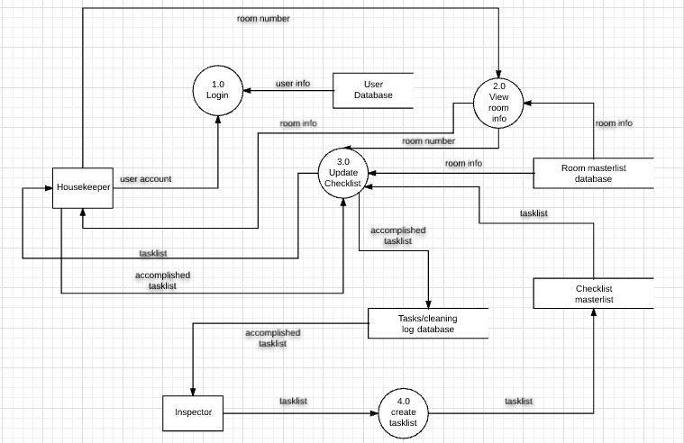

### **4.1.3 Entity-Relationship Diagram**

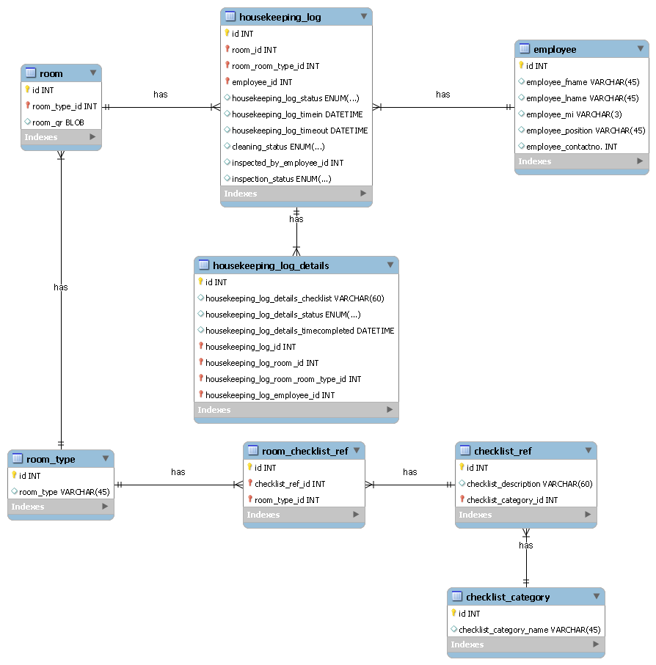Figure IV‑3

There can be many employees working in many rooms and there is a table named housekeeping_log that is a reference table for all the housekeeping records. The housekeeping_log has the room id and the employee id. It also has the status, the time in and time out, the cleaning status, and all the inspection details. The housekeeping_log table has a reference table called housekeeping_log_details where the checklist will be shown, the status of the checklist, and the time completed of each task. In the employee table, this includes the first name, last name, middle name, the employee’s position, and the email. The hotel has six room types and each room type has its own checklist items. The checklist_item has a reference table named checklist_ref that has the description of the checklist. The checklist_category table is the reference table for the checklist for each type of room.

## **Requirements Documentation**

### **4.2.1 Data Dictionary**

### **Room Table**

|  |  |  |  |  |
| --- | --- | --- | --- | --- |
| **Column Name** | **Column Type** | **Field Length** | **Constraint** | **Description** |
| Id | INT | 3 | Primary Key | Shows the room no. |
| Room_type | VARCHAR | 3 | Not null | Differentiates the types of room in the hotel |
| Room_qr | BLOB | 1 | Not null | For the qr code scanner |

Table IV‑1

### **Room Type Table**

|  |  |  |  |  |
| --- | --- | --- | --- | --- |
| **Column Name** | **Column Type** | **Field Length** | **Constraint** | **Description** |
| Id | INT | 3 | Primary Key | The primary key of the room type |
| Room_type | VARCHAR | 45 | Not null | Tell the types of room in the hotel |

Table IV‑2

**Housekeeping Log Table**

|  |  |  |  |  |
| --- | --- | --- | --- | --- |
| **Column Name** | **Column Type** | **Field Length** | **Constraint** | **Description** |
| Id | INT | 3 | Primary Key | Housekeeping log primary key |
| Housekeeping_log_status | ENUM | Completed, Not yet done | Not null | Status of the housekeeping log (completed or not completed) |
| Housekeeping_log_timein | DATETIME | mm:dd:yy 00:00:00 | Not null | Records the time in of employees |
| Housekeeping_log_timeout | DATETIME | mm:dd:yy 00:00:00 | Not null | Records the time out of employees |
| cleaning_status | ENUM | Completed, Not yet done | Not null | The status of housekeeping |
| inspected_by_employee | INT | 3 | Not null | Shows the inspector |
| Inspection_status | ENUM | Completed, Not yet done | Not null | Inspector status |

Table IV‑3

### **Employee Table**

|  |  |  |  |  |
| --- | --- | --- | --- | --- |
| **Column Name** | **Column Type** | **Field Length** | **Constraint** | **Description** |
| Id | INT | 3 | Primary key | Employee id, primary key |
| Employee_Fname | VARCHAR | 45 | Not null | First name of employee |
| Employee_Lname | VARCHAR | 45 | Not null | Last name of employee |
| Employee_MI | VARCHAR | 45 | Not null | Middle name of employee |
| Employee_Position | VARCHAR | 60 | Not null | Position of employee(housekeeper or inspector) |
| Employee_contactno. | VARCHAR | 100 | Not null | Contact number of employee |

Table IV‑4

### **Housekeeping log details Table**

|  |  |  |  |  |
| --- | --- | --- | --- | --- |
| **Column Name** | **Column Type** | **Field Length** | **Constraint** | **Description** |
| Id | INT | 3 | Primary Key | Housekeeping log id |
| Housekeeping_log_details_checklist | VARCHAR | 60 | Not null | Housekeeping log checklist details |
| Housekeeping_log_details_status | ENUM | Completed, Not yet done | Not null | Housekeeping log status |
| Housekeeping_log_detail_timecompleted | DATETIME | mm:dd:yy 00:00:00 | Not null | Housekeeping log date and time completed |

Table IV‑5

### **Checklist Items Table**

|  |  |  |  |  |
| --- | --- | --- | --- | --- |
| **Column Name** | **Column Type** | **Field Length** | **Constraint** | **Description** |
| Id | INT | 3 | Primary Key | Checklist items primary key |

Table IV‑6

### **Checklist Reference Table**

|  |  |  |  |  |
| --- | --- | --- | --- | --- |
| **Column Name** | **Column Type** | **Field Length** | **Constraint** | **Description** |
| Id | INT | 3 | Primary Key | Checklist reference primary key |
| Checklist_description | VARCHAR | 60 | Not null | Checklist descriptions |

Table IV‑7

### **Checklist Category Table**

|  |  |  |  |  |
| --- | --- | --- | --- | --- |
| **Column Name** | **Column Type** | **Field Length** | **Constraint** | **Description** |
| Id | INT | 3 | Primary Key | Checklist category primary key |
| Checked_category_name | VARCHAR | 45 | Not null | Checklist category type |

Table IV‑8

|  |  |
| --- | --- |
| **Name** | **Description** |
| **Ancillary** | Providing support to the primary activities or operation of an organization, institution or system. |
| **Byte code** | Computer object code that is processed by a program, usually referred to as a virtual machine, rather than by the "real" computer machine, the hardware processor |
| **Circular buffer queueing** | a data structure that uses a single, fixed-size buffer as if it were connected end-to-end |
| **Grid Computing** | The collection of computer resources from multiple locations to reach a common goal? |
| **Java Virtual Machine** | Is an abstract computing machine that enables a computer to run a Java program |
| **Module** | A module is a separate unit of software or hardware. Typical characteristics of modular components include portability, which allows them to be used in a variety of systems |
| **Monolithic systems** | A [software system](https://en.wikipedia.org/wiki/Software_system) is called "monolithic" if it has a monolithicarchitecture, in which functionally distinguishable aspects |
| **User-friendly interface** | Refers to anything that makes it easier for novices to use a computer. |
| **Streamline** | To make (an organization or system) more efficient and effective by employing faster or simpler working methods. |
| **SM Hotels** | SM Supermalls, owned by [SM Prime Holdings](https://en.wikipedia.org/wiki/SM_Prime_Holdings), is a chain of shopping malls in the [Philippines](https://en.wikipedia.org/wiki/Philippines) that has 62 malls located across the country and 6 in [China](https://en.wikipedia.org/wiki/China). |

### **4.2.2 Glossary**

Table IV‑9

### **4.2.3 Tables/Files Layout**

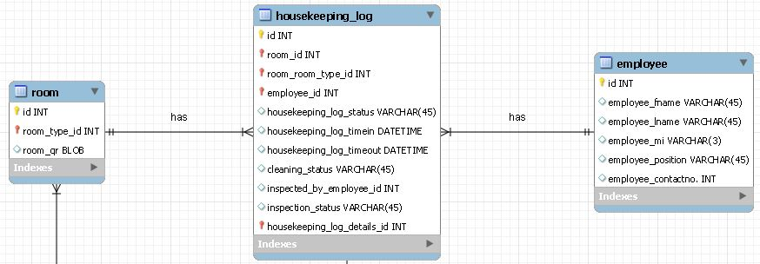

The room table and the employee table has a ‘many-to-many’ relationship. Therefore, there will be a bridge table that the group will name as the housekeeping_log table. The housekeeping_log table has all the details of inspector and housekeeper log that will be generated by the mobile application.

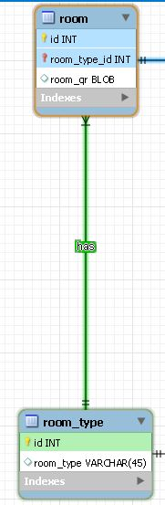

The hotel room has six different room types so there is a reference table for the room types named ‘room_type’

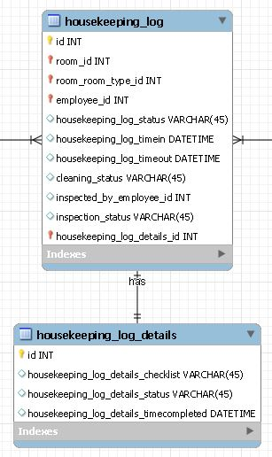

The housekeeping_log table has reference table for all the details included for the housekeeping log. The reference table is named as ‘housekeeping_log_details’ that has the checklist, status, and the time completed in the DATETIME format.

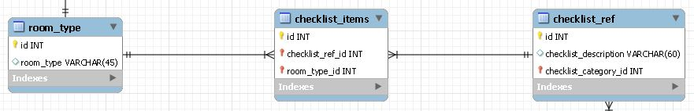

The room_type table and the checklist_ref table has a ‘many-to-many’ relationship. Therefore, there will be a bridge table that the group will name as checklist_items that contains the items in the checklist. The checklist_ref table is the reference table for all the checklist which contains the description of each task.

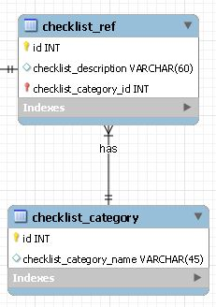

The checklist_ref table is connected to the checklist_category table in which the table distinguishes the checklist for each type of room.

### **4.2.4 Use Case Diagram**

Figure IV‑4

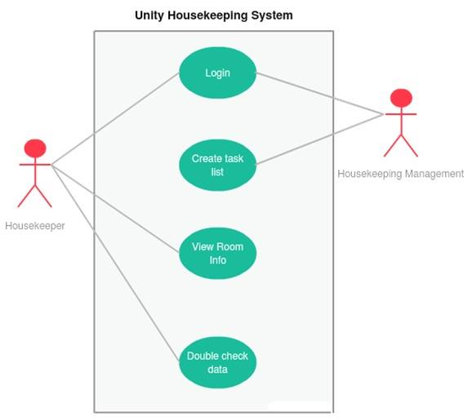

### **4.2.5 Use Case Narrative Report**

|  |  |  |  |
| --- | --- | --- | --- |
| Use Case Number | | **1** | |
| Use Case Name | | **Login** | |
| Author | |  | |
| Super Use Case | | N/A | |
| Actor | | Housekeeper or Inspector | |
| Brief Description | | This use case describes the procedure in logging in the system or application. | |
| Pre-conditions | | An authorized user has access to the application. | |
| Post-conditions | | User will now be logged in the system. | |
| **Basic Flow** | | **Action** | **System Response** |
|  | 1 | Enters user credentials in the Login page |  |
| 2 |  | Displays a page containing the following details:  *Username:*  *Password:*  *“Please fill out the form above” text*  *LOGIN button*  *Help button* |
| 3 | Fills all the details required then press the ‘LOGIN’ button. |  |
| 4 |  | Validates the user credentials |
| 5 |  | Displays a message that says “You are now logged in!” |
| **Alternate Flow** | | **Action** | **System Response** |
|  | 1 | In step 4, username and password is not validated |  |
| 2 |  | Displays a message that says “Invalid login credentials.” |
|  | 3 |  | Go back to step 1 on Basic Flow |
|  | 4 | In step 4, user enters no username or password |  |
|  | 5 |  | Displays a toast message that says “No username entered.” Or “No password entered.” |
|  | 6 |  | Go back to step 1 on Basic Flow |
|  | 7 | In step 4, if the user is a housekeeper |  |
|  | 8 |  | Go to View Room Info page |
|  | 9 | In step 4, if the user is an inspector |  |
|  | 10 |  | Go to Create task list page |

Table IV‑10

|  |  |  |  |
| --- | --- | --- | --- |
| Use Case Number | | **2** | |
| Use Case Name | | **Create task list** | |
| Author | |  | |
| Super Use Case | | N/A | |
| Actor | | Inspector | |
| Brief Description | | This use case describes the procedure in creating a task list or check list for each type of hotel room in the system. | |
| Pre-conditions | | An authorized user has already logged in the system to access the application. | |
| Post-conditions | | A check list will now be generated. | |
| **Basic Flow** | | **Action** | **System Response** |
|  | 1 | Goes to the Main Menu after they log in |  |
| 2 |  | Displays the task list page that has the following:  A dropdown that lets the user choose from the following:  *Two-Bedroom Deluxe Suite*  *Premier Queen*  *Deluxe King*  *Deluxe Queen*  *Premier King*  *Batangas Suite*  Displays a ‘Generate’ button  Displays a text field that will let the user add another task. |
| 3 | Chooses the type of room the inspector wishes to edit or create a task list from the dropdown list. |  |
| 4 |  | Displays the dropdown list of all types of room. |
|  | 5 | Fills the details and input all the task list for each type of hotel room. |  |
|  | 6 |  | Validates the length of text of each task |
|  | 7 |  | Displays the message that shows all the task that are placed by the user in a check list format |
|  | 8 | Presses the ‘Generate’ button. |  |
|  | 9 |  | Generates a new check list |
|  | 10 |  | Displays a toast that has a message saying “The check list has been generated.” |
| **Alternate Flow** | | **Action** | **System Response** |
|  | 1 | Generates the check list |  |
| 2 |  | Let’s the user add or edit some task/s |

Table IV‑11

|  |  |  |  |  |
| --- | --- | --- | --- | --- |
| Use Case Number | | | **3** | |
| Use Case Name | | | **View Room Info** | |
| Author | | |  | |
| Super Use Case | | | N/A | |
| Actor | | | Housekeeper | |
| Brief Description | | | This use case describes how the QR code scanner works in the application. | |
| Pre-conditions | | | An authorized user has already logged into the system to access the application. | |
| Post-conditions | | | A message will display all the information in each type of hotel room that is scanned by the QR code scanner | |
| **Basic Flow** | | | **Action** | **System Response** |
|  | | 1 | Presses the ‘Scan QR Code’ button |  |
|  | | 2 |  | Displays the QR Code scanner |
|  | | 3 | Scans the QR Code besides the room number |  |
| 4 |  | Validates the type of room |
| 5 |  | Displays the ‘Update Checklist’ page that has the following information:  *Housekeeper’s Name*  *Time/Duration*  *Check list*  *Update button* |
| 6 | Ticks the box of the task that is already been done by the user(housekeeper) |  |
| 7 | Presses the ‘Update’ button after finishing all the task required in the hotel room |  |
| 8 |  | Validates the check list |
| 9 |  | Displays another page that shows the “You have successfully updated the checklist!” message  Displays a ‘Go back to QR Scanner’ button  Displays a ‘Logout’ button |
| 10 |  | Sends the check list to the Inspector for the double checking of data |
| 11 | Press the ‘Go back to QR Scanner’ button |  |
| 12 |  | Goes back to the QR code scanner page |
| **Alternate Flow** | | | **Action** | **System Response** |
|  | 1 | | In step 6, user ticks a box that is already ticked |  |
| 2 | |  | Validates the check list |
| 3 | |  | Displays a toast that says “Task is already checked and completed.” |
|  | 4 | | In step 7, the housekeeper presses the ‘Update’ button even if he/she didn’t finished the task. |  |
|  | 5 | |  | Validates the check list |
|  | 6 | |  | Displays a toast message that says “Please complete all the tasks first” |
|  | 7 | | In step 9, the housekeeper presses the ‘Logout’ button instead of the ‘Go back to QR Scanner’ button |  |
|  | 8 | |  | Goes back to the Login page. |

Table IV‑12

|  |  |  |  |  |
| --- | --- | --- | --- | --- |
| Use Case Number | | | **4** | |
| Use Case Name | | | **Double check data** | |
| Author | | |  | |
| Super Use Case | | | N/A | |
| Actor | | | Housekeeping Management | |
| Brief Description | | | This use case describes the process of the housekeeping management in double checking the information or data of each hotel room. | |
| Pre-conditions | | | The housekeeper has already sent the data for each hotel room.  Back-end already received the data of the hotel rooms. | |
| Post-conditions | | | Room status and productivity of housekeeper will have a final update before rooms can be occupied by guests. | |
| **Basic Flow** | | | **Action** | **System Response** |
|  | | 1 | Checks data in the framework of the whole Taal Vista Hotel system |  |
| 2 | Presses the ‘Housekeeping’ tab |  |
| 3 |  | Displays the following:  *Room number*  *Room status*  *Type of hotel room* |
| 4 | Presses a room number that is not yet occupied and check the hotel room |  |
|  | | 5 |  | Receives the data from the housekeeper |
|  | | 6 | Presses the ‘Update’ button in the website after checking the hotel room |  |
|  | | 7 |  | Generates an updated task list with the room status |
|  | | 8 |  | Displays a message that says “Room is now ready to be occupied.” |
| **Alternate Flow** | | | **Action** | **System Response** |
|  | 1 | | In step 1, checks the data but is not accurate or there are tasks that are not yet done |  |
| 2 | |  | Updates the system and transfers it to the mobile application for a re-cleaning. |

Table IV‑13

### **4.2.6 User Stories**

|  |  |  |
| --- | --- | --- |
| **As an** | **I want to** | **So that** |
| Inspector | create the task list for ever type of room in Taal Vista Hotel | the housekeeper will have a check list for each type of room |
| Inspector | double check the data given by the housekeeper | they can monitor the productivity level of housekeepers |
| Inspector | set and assign each housekeeper to their designated hotel room | there will be a proper rotation of each housekeeper in the hotel |

Table IV‑14

|  |  |  |
| --- | --- | --- |
| **As a** | **I want to** | **So that** |
| Housekeeper | clean the room | the hotel can provide their guests with clean and comfortable surrounding |
| Housekeeper | comply the requirements of the check list given by our inspector | there will be a proper tracking of productivity level |

Table IV‑15

## **Gap Analysis**

|  |  |  |  |
| --- | --- | --- | --- |
| **HOTEL ROOM CLEANING MODULE** | | | |
| **User Requirements** | **Current System** | **Goal** | **Proposed Changes** |
| 1. Track productivity level of housekeepers | Housekeepers manually check the cleanliness of each hotel room based on paper checklists, which produce inaccurate records | To have an accurate record of cleaning status | Unity Housekeeping System will provide housekeepers with an automated check list that lets them track their own time and will help in boosting their productivity |
| 2. Distribute task list to housekeepers | Inspectors manually distributes task to each housekeeper | To have a system that will help the inspectors generate a check list for housekeeper | Unity Housekeeping System is used as a mobile application that will let the inspectors generate a check list and distributes it easily to the housekeepers |
| 3. Double check data given by the housekeepers | Inspectors manually checks each room and only uses a paper and pen when there is a task that is not completed and produces inaccurate tracking of tasks | To have an accurate track of each tasks given to the housekeepers | Unity Housekeeping System aims to have an automated task list for each type of hotel room and lets the inspectors edit each task within the system. This will let the inspectors produce a consistent distribution of task and an easier way of tracking |

Table IV‑16

## **Design of Software, Systems, Product, and/or Processes**

**Loading** **Screen**

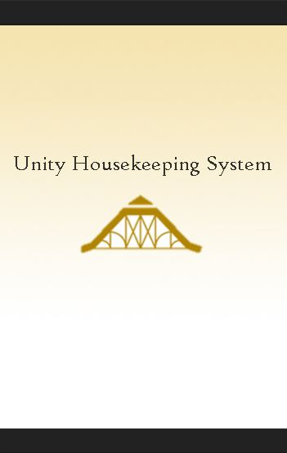

**Login**

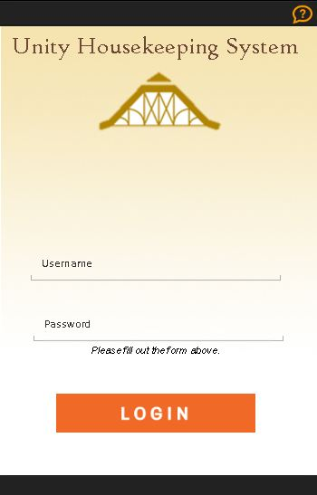

**Scan** **QR**

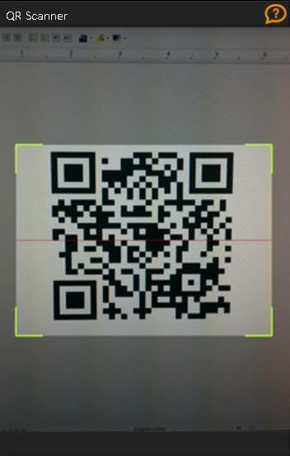

**Update** **Checklist**

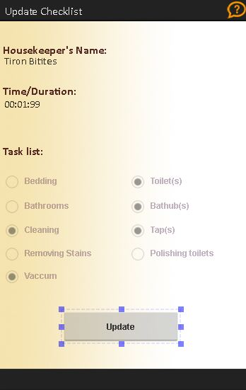

**Update** **Checklist** **Error**

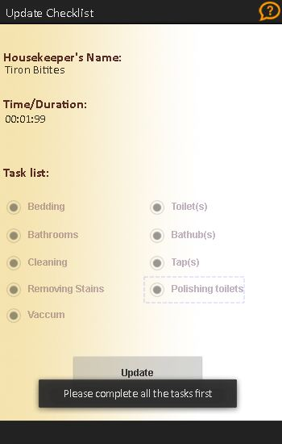

**Update** **Success**

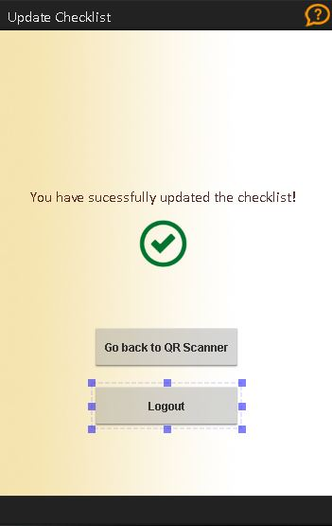

**User** **Manual** **1**

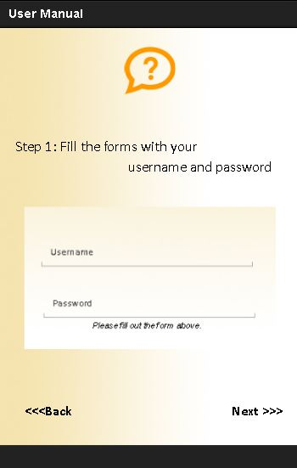

**User** **Manual 2**

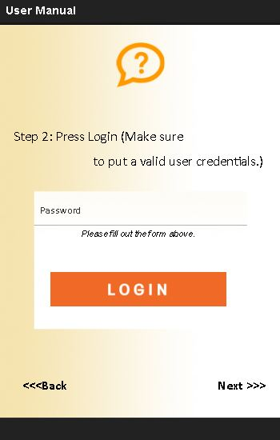

**User Manual 3**

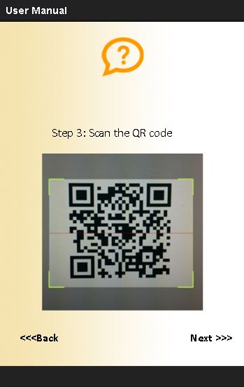

**User Manual 4**

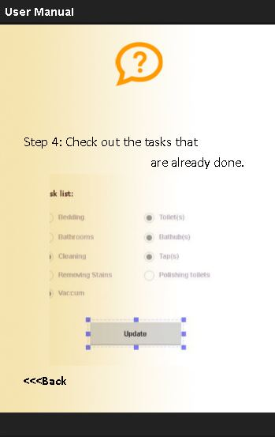

## **Description of the Prototype**

* + 1. **User Manual**

Features

**Login Screen**

The Housekeeper will use their user id to access the application

 

**Scan QR Code**

The function of Scan QR Code is to get the room information of each hotel room. It will also record the housekeeper’s productivity level using the time in and time out of every task they do.



**Update Checklist**

The Housekeeper will use this feature to update unfinished task-list the previous housekeeper did not finish. The Housekeeper will double check every room to check and update every unfinished task available.



**Features (ADMIN side)**

**Create Task-list**

The administrator of the housekeeping system will generate tasks to each room type for the housekeepers to clean.

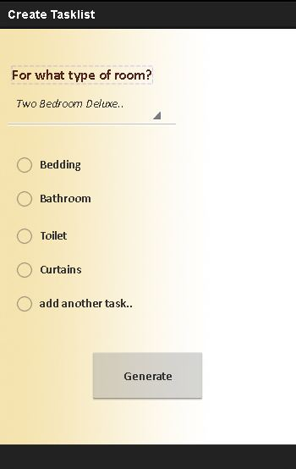

## **Sequence Diagram**

**Login**

Figure IV‑5

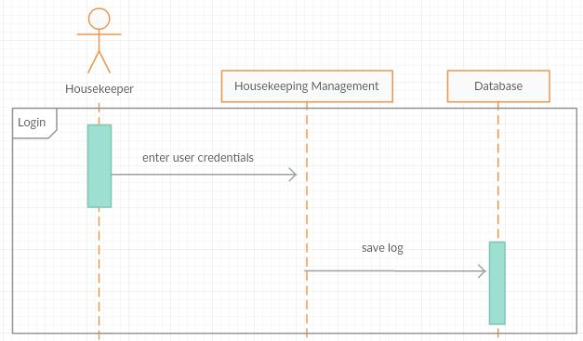

**Create Task Lists**

Figure IV‑6

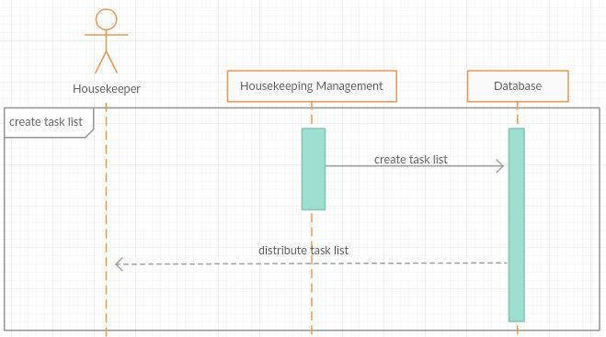

**View Room Info**

Figure IV‑7

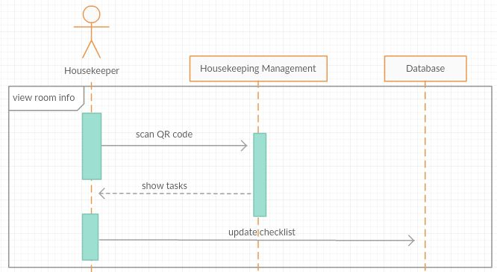

**Double Check Task Lists**

Figure IV‑8

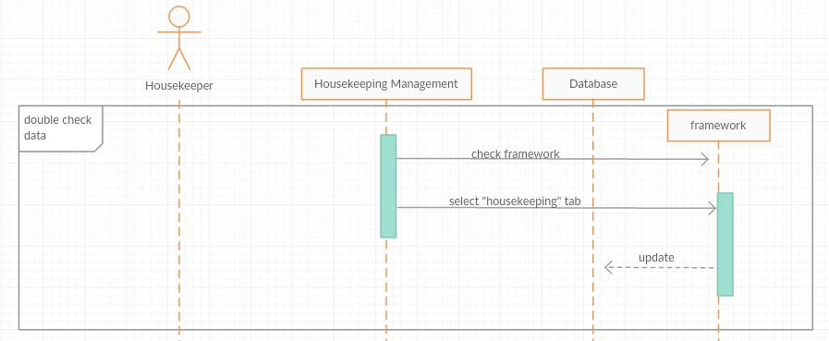

## **4.7 Activity Diagram**

**Login**

Figure IV‑9

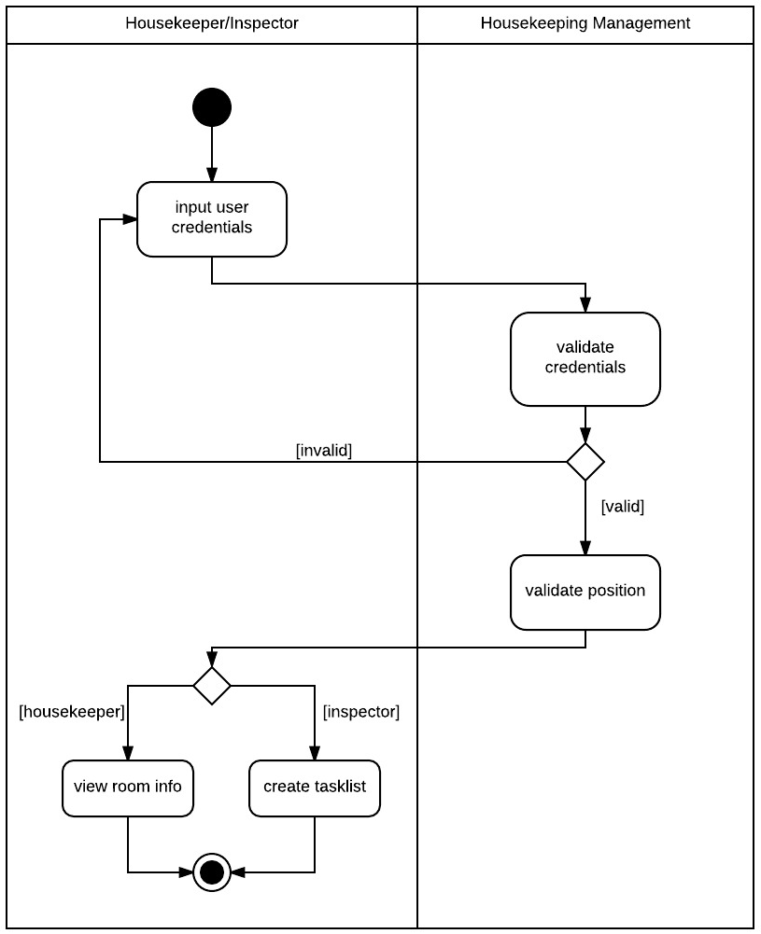

**Create Task Lists**

Figure IV‑10

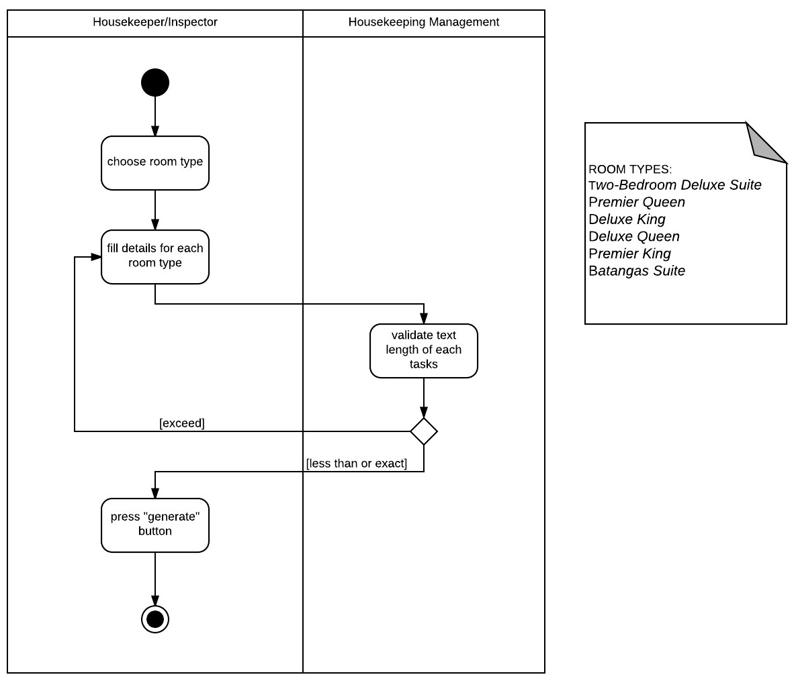

**View Room Info**

Figure IV‑11

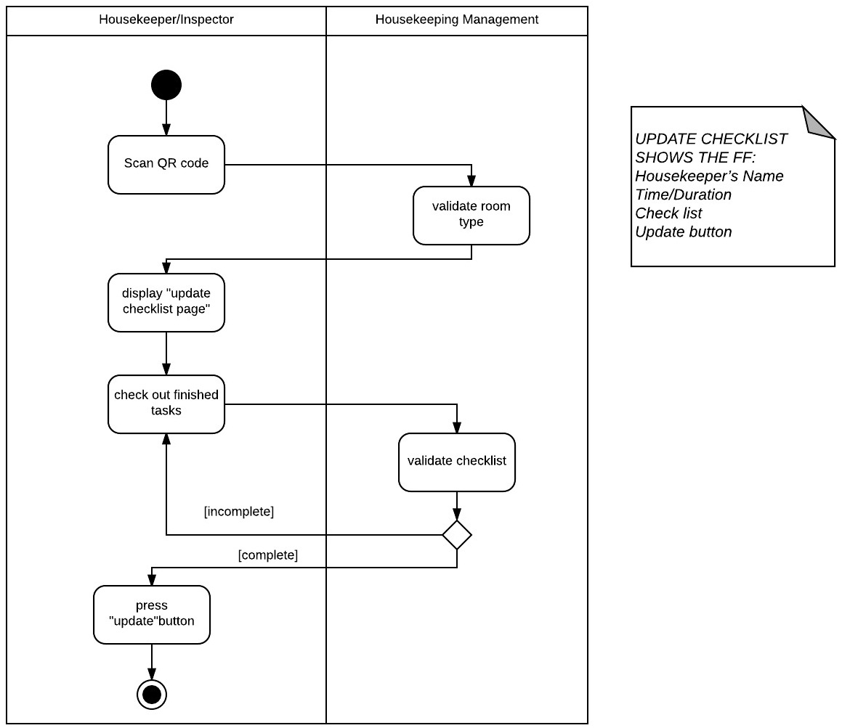

**Double Check Data**

Figure IV‑12

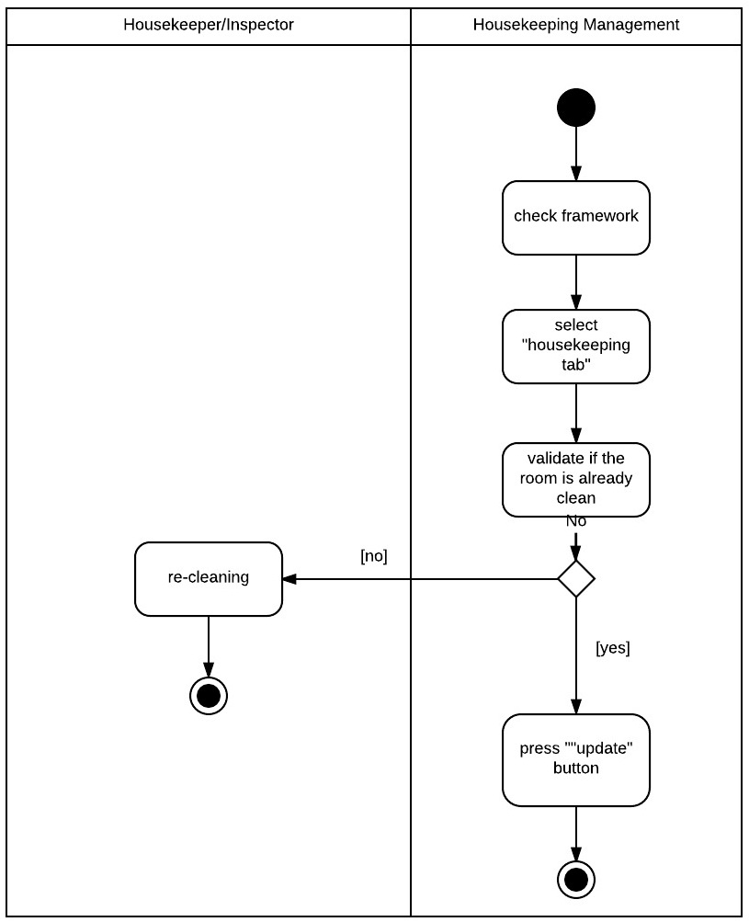

## **Proposed Conceptual Framework**

Figure IV‑13

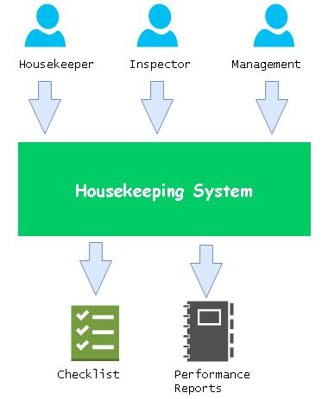

## **Gantt Chart**

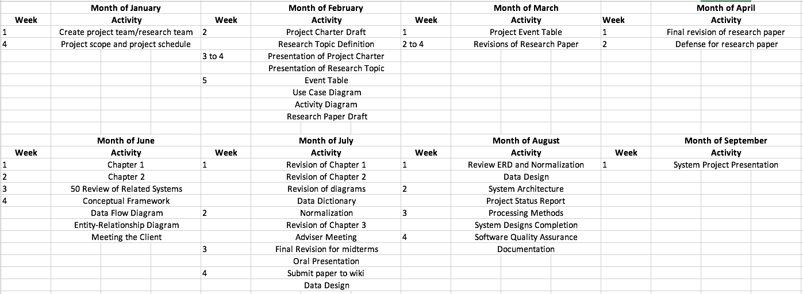

# Conclusions and Recommendations

The Unity Housekeeping System is a great addition to the Taal Vista hotel as it will help the employees, specifically, the housekeepers and the inspectors of the room. The Unity Housekeeping System is better than having a manual tracking of records of the employee’s work which the Taal Vista Hotel has as their old process of tracking. The system will help the employees in many factors like the quick response of each employee and a better tracking of performance reports of the employees. Based on what the group completed, the system will definitely change how the employees work in a better way and in a more innovative approach in the hotel. Though the system can only do that much, there will always be room for improvement. The real-time update can be enhanced by providing or using a much more improved technology like the face scanner that will be used inside the system.

# Appendices

**6.1 Sample input/output reports**

|  |  |
| --- | --- |
| INPUT | OUTPUT |
| Admin Creates checklist | Housekeeper updates checklist if they did the job or not |

**6.2 Users Guide**

Overview of the Application

The Mobile application we made is divided into two modules the first is for the admin and another is for the housekeepers. Inside the Admin module it contains create task list where the administrator will create task for the housekeepers. Meanwhile Housekeeping module contain Scan QR code and update checklist. The housekeeper will basically scan the QR code to measure their duration of work for their performance report purposes. After scanning they will update the remaining task using the update checklist to finish their work.

Basic Steps for Administrator

1. Login their user credentials.
2. Create task-list according to their decision.

Basic Steps for Housekeeper

1. Login their user credentials.
2. Scan QR code to trigger their starting time.
3. Update Checklist to finish task.

**PERSONAL DETAILS**

Name: Garcia, John Ryan L.

Place of Birth: Taguig

Sex Male

Contact number 09053523664

Email: jlgarcia@student.apc.edu.ph

**EDUCATION**

* Bachelor Science of Information Technology Specialized in Mobile and Internet Services (currently taking)
* Sto Niño Catholic School (2011-2015)

**Other Skills**

* Java Programming
* Technical Support
* Web Design

 **PERSONAL DETAILS**

Name: Betita, Tyronne U.

Place of Birth: Laguna

Sex Male

Contact number 09985741730

Email: tyronnebetita@gmail.com

**EDUCATION**

* Bachelor Science of Information Technology Specialized in Mobile and Internet Services (currently taking)
* Colegio San Agustin Biñan (2011-2015)

**Other Skills**

* Flexible
* Java Programming
* Network Troubleshooting

**PERSONAL DETAILS**



Name: Gonzaga, Earl Peter O.

Place of Birth: Makati

Sex Male

Contact number 09954260425

Email: eogonzaga@student.apc.edu.ph

**EDUCATION**

* Bachelor Science of Information Technology Specialized in Mobile and Internet Services (currently taking)
* Paco Catholic Highschool (2011-2015)

**Other Skills**

* Leadership
* SQL Programming
* Java Programming

**PERSONAL DETAILS**



Name: Famador, Jimmy M. Jr.

Place of Birth: Pasay

Sex Male

Contact number 09215957067

Email: jmfamador@student.apc.edu.ph

**EDUCATION**

* Bachelor Science of Information Technology Specialized in Mobile and Internet Services (currently taking)
* Pasay City South High-school (2011-2015)

**Other Skills**

* Decision Making
* Web Design
* Java Programming

# VII. Bibliography

B, B. (2000). *Property Management Simplified*. Retrieved from Hotelogix: http://www.hotelogix.com/

*Carter Casino*. (2016). Retrieved from http://cartercasino.com/hotel/rates-and-information

*Ciircus*. (2017). Retrieved from https://www.ciirus.com/about-us.aspx

Connerly, C. (2003). *Living Learning in Community*. Retrieved from http://legacy.earlham.edu/~kohlhe/blog/archives/000768.html

Crig. (2005). *Factory Systems*. Retrieved from factory systems: https://www.factorysystems.eu/index-en.php?id=5s-en

Dehan J, D. W. (n.d.).

Dehan J, D. W. (2015). *Maestro*. Retrieved from http://www.maestropms.com/?q=press-release/maestro-pms-users%E2%80%99-conference-2015-ah-ha-moments-everyone

Divina. (2015). *Momvoyage*. Retrieved from http://momvoyage.hilton.com/about-us

*Djumbo*. (2015). Retrieved from http://www.littlehotelier.com/

*Elina Hotel*. (2011). Retrieved from http://www.elinahotel.gr/default.aspx?langid=2

*Fairmont Hotel Housekeeping*. (1999). Retrieved from Fairmont: http://www.fairmont.com/

Granholm. (2011). *HIBOX Housekeeping*. Retrieved from Hibox: http://www.hibox.tv/index.shtml

*GuestPoint*. (2016). Retrieved from http://www.guestpoint.com/

*HHS Housekeeping*. (1975). Retrieved from https://www.hhs1.com/

Hohman, R. (2007). *Starwood Hotel & Resorts*. Retrieved from Starwood: https://www.glassdoor.com/Hourly-Pay/Starwood-Hotels-and-Resorts-Housekeeping-Hourly-Pay-E335_D_KO28,40.htm

*Hotel Housekeeping Inspection Software*. (2006). Retrieved from inspect2go: http://inspect2go.com/hotels/housekeeping-software

*Hotel Management System*. (2006). Retrieved from Trigernix: https://www.tigernix.com/home/software/hotel-management-system

*Hotello*. (2017). Retrieved from http://mingus-software.com/en/hotello/

*Janiking*. (2017). Retrieved from https://www.janiking.com/commercial-cleaning-services/hotel-and-resort-housekeeping/

Khaled. (2010). *Room Key PMS*. Retrieved from Room Key PMS: http://support.roomkeypms.com/

*Little Hotelier*. (2006). Retrieved from http://www.littlehotelier.com/

McLean. (1993). *acgil*. Retrieved from http://www.acgil.com/products/smart_deals.htm

McLean. (n.d.). *acgil*.

Midjili. (2012). *Mobile Operation Platform*. Retrieved from http://www.lodgingcontrols.com/

Midjili. (n.d.). *Mobile Operation Platform*. Retrieved from http://www.lodgingcontrols.com/

*Modern Housekeeping* . (2008). Retrieved from FCSCS: https://www.fcscs.com/e-housekeeping/?gclid=Cj0KCQjw7pHLBRDqARIsAFyKPa6JKWDnUgIUx_L7fGi-sl5hsjthBc1HZBWKNET6DOtMFbfj5nAOMgIaAhLxEALw_wcB

*Online Hotel Property Management System*. (2009). Retrieved from Snap PMS: http://www.snappms.com/

*Payscale*. (2017). Retrieved from http://www.payscale.com

*Peek Housekeeping*. (2015). Retrieved from https://peekpro.com/booknow

*Prologic Housekeeping*. (2012). Retrieved from Prologic: http://www.prologicfirst.com/news/Hotel-Software-for-Smartphones.html

*Protel Housekeeping*. (2017). Retrieved from http://www.protel.net/

*Resort Data Processing*. (1998). Retrieved from RDP: http://www.resortdata.com/

Ridge. (2012). *Housekeeping Schedules*. Retrieved from Home Sanctuary: http://www.homesanctuary.com/rachelanne/2011/09/housekeeping-schedules-and-daily-home-management.html

*RoomMaster*. (2017). Retrieved from http://roommasterpms.co.uk/

*Silk Hospitality*. (1998). Retrieved from http://www.silkhospitality.com.au/why-outsource-housekeeping-services

*SmartButler*. (1989). Retrieved from http://jaybee.com/

*SMS Service Management*. (2009). Retrieved from Service Management: https://www.fieldaware.com/

*The Optimum Housekeeping Solution*. (2011, July). Retrieved from Optii Keeper: http://optiisolutions.com/

Thompson. (2011). *Grandmeneng*. Retrieved from http://www.grandmeneng.com

*Waterfront*. (1995). Retrieved from Waterfront Hotels: http://www.waterfronthotels.com.ph/

*WebRezPro*. (2003). Retrieved from https://www.webrezpro.com/

Winterhalter. (1947). *Winterhalter housekeeping*. Retrieved from winterhalter: http://www.winterhalter.biz/

*World Hotels*. (n.d.). Retrieved from http://www.payscale.com

*World Hotels*. (2017). Retrieved from http://www.payscale.com

*Xotelia*. (2015). Retrieved from https://www.xotelia.com/